**Name of the event :** Creators Camp 2.0

**Date of the event :** 10th November 2022

**Venue of the event:** EC Conference Hall , AB2

**No. Of Attendees :** 450 approx.

**Organized by :** Entrepreneurship Cell , GLAU

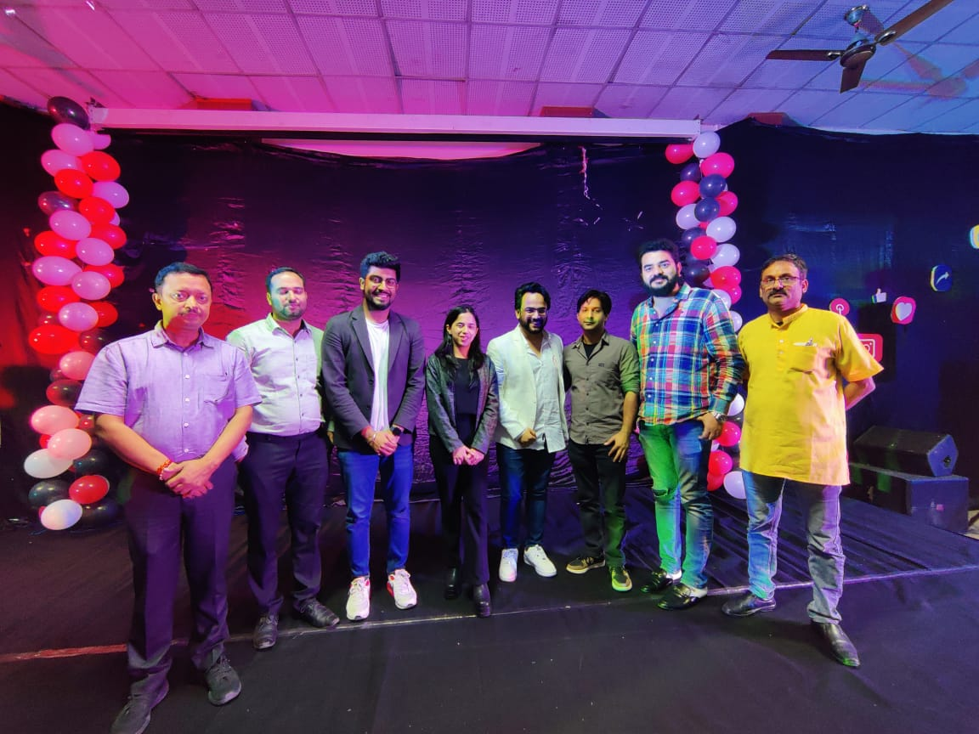

**Summary of the event :**

On 10th of November Entrepreneurship Cell of GLA University organized an event named **“Creators Camp 2.0”**. This event was organized to guide the students on the path of being a Creator. To serve this purpose, we had multiple Creators from different fields. The event was started by the anchors of the Event Kushagra Sharma and Pranjali Srivastava. The evening was started by lighting the lamp to seek the choicest blessings of Goddess Saraswati.

First of all, the audience was given a brief introduction to what a Creator is; and The Creators aka The Speakers were introduced to the audience as well.

Listening & interacting with successful Creators is always inspiring, knowledgeable and fun as well.

The Event started with a melodious performance by the NINAD club , they performed three songs delightfully.

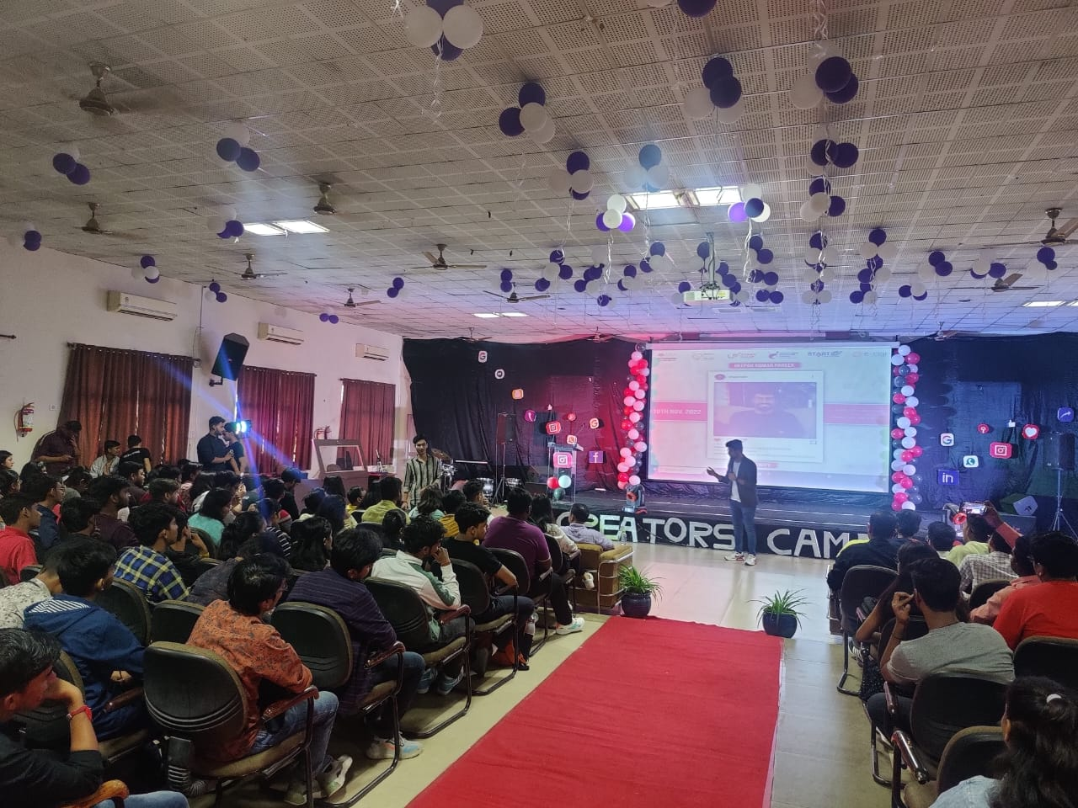

After the performance our first speaker **Mr. Deepak Pareek**was called upon the stage, he’s an Entrepreneur, a Vlogger, a Keynote speaker and a Cricket enthusiast as well. He is the **Co-founder of Media Production House**of **Iceberg Creations**.

 He has delivered 100+ sessions on content creation, Entrepreneurship, personal branding, public speaking and much more in colleges and organizations like TEDx, Lions clubs international, IIT Kanpur, IIT Bombay, IIM Calcutta and many more.

He has worked with many brands across various domains like FinTech, EdTech, Banking, Travel, Telecommunication, etc.

He shared his journey from the very beginning where we got to know that he has also prepared for CA, he used the slang “**I was doing engineering by commerce** ”.

He interacted with the audience with great enthusiasm, he was also asked about his life behind the cam, to which he replied that he experiences the same life just as we all do. He shared that his life’s **first ever pitch was to his parents**, he wanted to become a Youtuber then.

He quoted **“ Shuru sab zero se karte hai ”** which was an amazing answer to one’s query that “no one will support me in my journey”. but also he told us all the importance of having a **Backup Plan**. He included points like Personal Branding, Visibility and Credibility. We got to know that his first startup was **“Career Keeda”**  where he generated no revenue for the first two years. He concluded his session stating we must not hurry in life, quoting **“ Play it like a Test Match , not like T20 ”**.

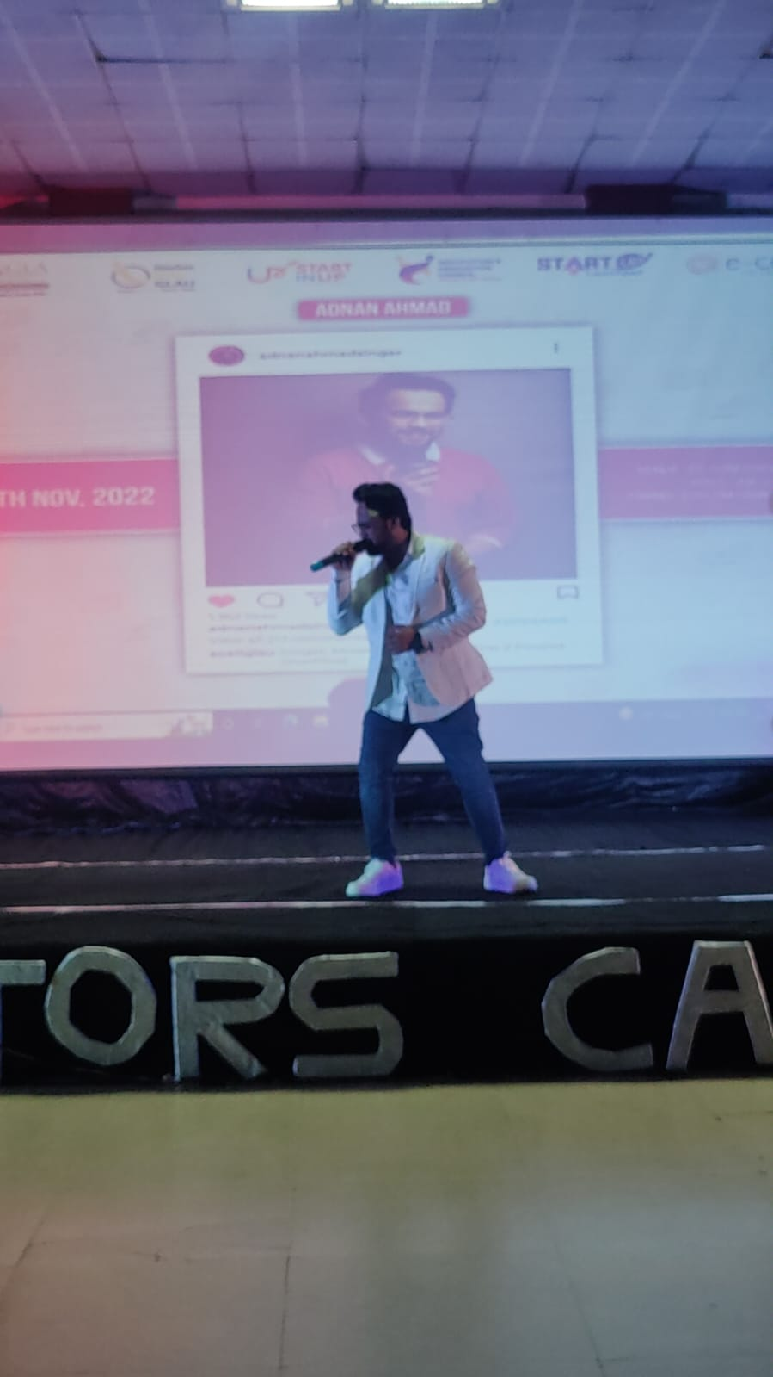

Then moving forward to our second Creator, **Mr. Adnan Ahmad**was called upon the stage.

He is a well-known Singer, known for his melodious voice, he has been on reality shows like **“ The Voice ”**, he is also the winner of **“ Sing Dil Se S2 ”**, he has loved music since his childhood and his love towards music gave rise to his interest in building a career in Music Industry only.

His session was much more focused on self-motivation, he stated “Some will like your work, Some will love it and Some will hate it, just**don’t be disheartened by dislikes,**keep working on your content ” dislikes are the proof that there’s still a requirement of improvement to conquer it all.

He performed a great melody, the audience was mesmerized by his voice.

After these two sessions, NATRAJ club carried out great dance performances.

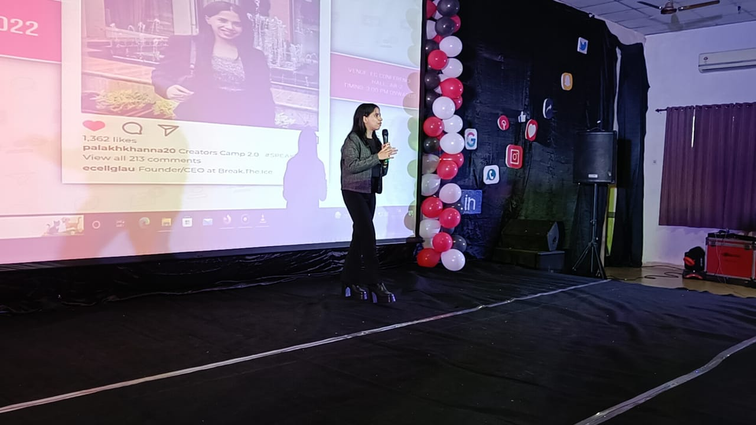

Moving forward with the event, our third speaker **Ms. Palakh Khanna**, a regional officer, social entrepreneur, youth change maker, poet, writer, **founder & CEO at Break.The.Ice.**

She’s a 19 year old, world record holder, an India’s 20 under 20 and a regional officer for Asia pacific, **awarded with the pride of nation award** for social impact. She has been featured in the US Times Now, The Hindu and Global Indian amongst others.

She has been the **youngest panelist** for a govt. Of Delhi program.

She initiated her session by guiding the audience on how to become a **creator as a student**.

As many of us worry about not having a plan, she comforted all by stating that she never had a plan,**“ You don’t need to have everything planned ”**, but this does not mean that we should stay still and not reach out to our goals, to achieve something **“ One must step out of its comfort zone ”**.

As she was just the same age as the majority of the audience, a question that everybody had in their mind was, what to sacrifice to achieve at a such young age; to which she replied: **“ It's never about sacrifice, it is just about the prioritization ”**.

Also, she advised the attendees to always keep a **To-Do-List**and just so that while prioritizing things in our life we shall not forget the less important things.

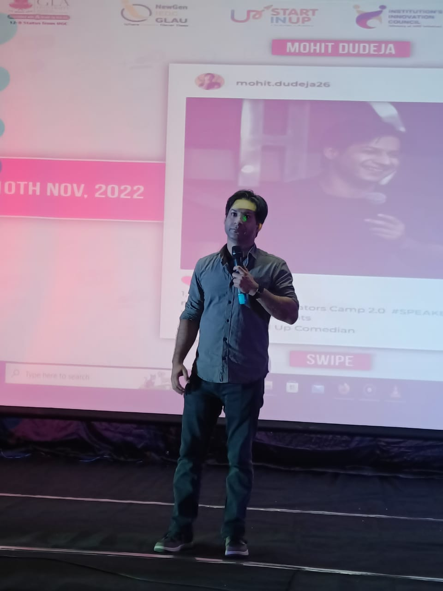

And **last but not the least**, **Mr.Mohit Dudeja** was invited onto the stage. His session was amazingly engaging, his jokes were hilarious and his “**Car Tale”**  was a memorable performance for every single attendee.

After all the sessions and performances, Dr. Manoj Kumar sir presented a glimpse of **TEDxGLAU**to the attendees. Everyone: the attendees, mentors, guests and the E-Cell, GLAU, enjoyed it. Overall the event was organized successfully.